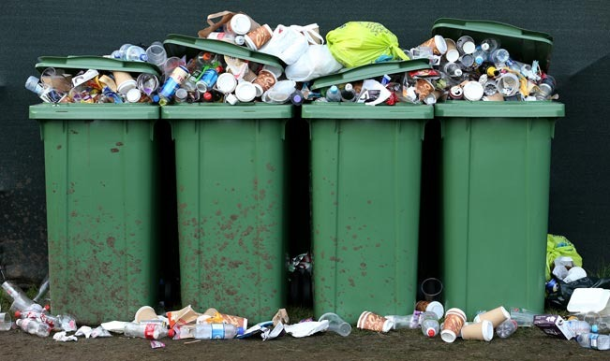
No
yes
Send notification and message to officials

Check if garbage level is full
Display garbage level of bin and its location
Connect to cloud database
sensing

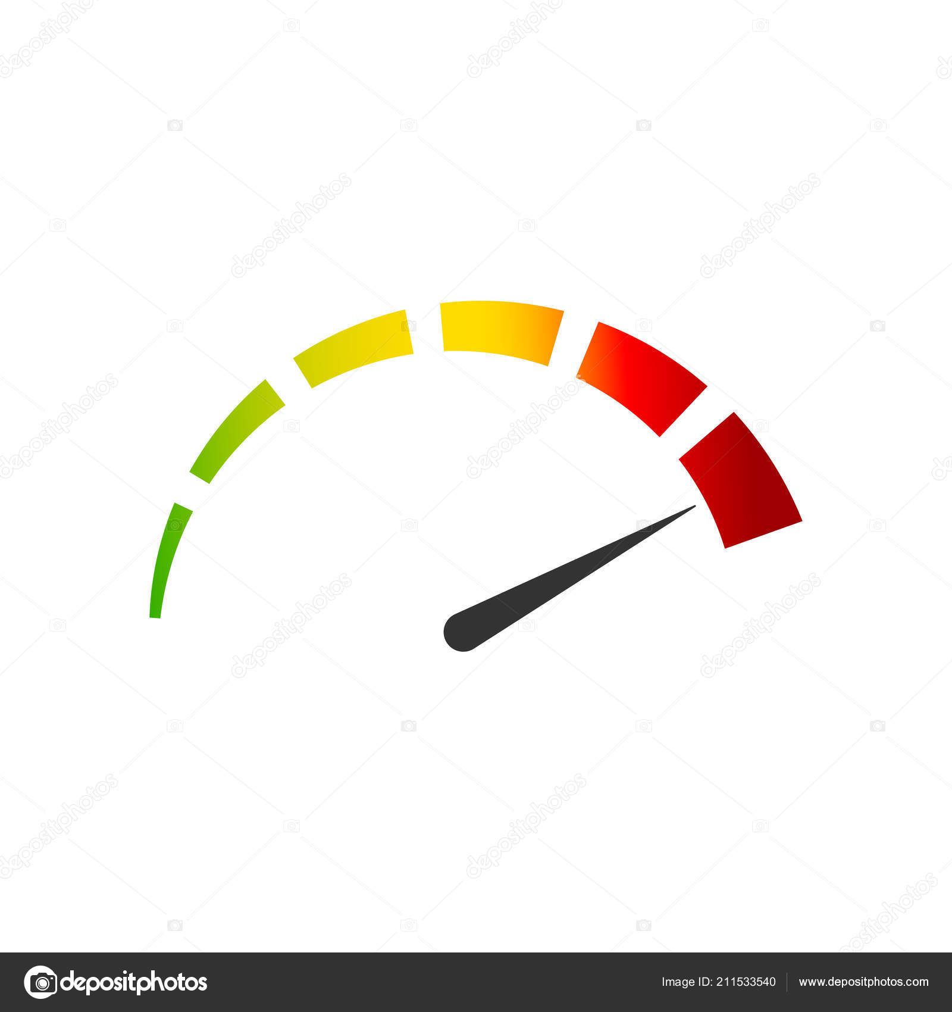



BLOCK DIAGRAM

OVERVIEW:
Waste management is all the activities and actions required to manage waste from its inception to its final disposal. This includes collection, transportation, treatment and disposal of waste together with monitoring and regulation. Waste collection methods vary widely among different countries and regions. Domestic waste collection services are often provided by local government authorities. Curbside collection is the most common method of disposal in most countries, in which waste is collected at regular intervals by specialised trucks. Waste collected is then transported to an appropriate disposal area. Nowdays, cities with developing economies experience exhausted waste collection services, inadequately managed and uncontrolled dumpsites and the problems are worsening. Waste collection method in such countries is an on-going challenge and many struggle due to weak institutions and rapid urbanization.

NEED FOR IMPROVEMENT IN WASTE MANAGEMENT SYSTEM 
By 2030, almost two-third of the world’s population will be living in cities. This fact requires the development of sustainable solutions for urban life, managing waste is a key issue for the health.  Efficient and energy-saving waste management, reducing CO2,air pollution and vehicle exhaust emissions—these are just a few examples for the demands of future cities. In views of that, the efficient use and responsible handling of resources become more important.  Effectively managing waste is important in developed countries. Waste management may swallow upto 50% of a city’s budget, but only serve a small part of the population.  Sometimes, upto 60%of waste is not being collected, it is often simply burned by the roadside. It can pollute drinking water, it can spread disease to people living nearby.  Even with great route optimization, the worker must still physically go to the dustbin to check waste levels. Because of this, trucks often visit containers that do not need emptying, which wastes both time and fuel.  Waste management prevents harm to human health and the environment by reducing the volume and hazardous character of residential and industrial waste.Improving proper waste management will reduce pollution, recycle useful materials and create more green energy.

FEATURES OF SMART WASTE MANAGEMENT SYSTEM:
The smart, sensor based dustbin will judge the level of waste in it and send the messege directly to the municipal corporation.  It can sense all the type of waste material either it is in the form of solid or liquid.  According to the filled level of the dustbin, the vehicles from the municipal corporation will choose the shortest path with the help of the “TRANSPORTATION SOFTWARE”, which will save their time.  It emphasizes on “DIGITAL INDIA”.  The system is simple. If there is any problem with any equipment in the future, that part is easily replaceable with new one without any difficulty and delay.

ADVANTAGES OF SMART WASTE MANAGEMENT SYSTEM;
❖ Less time and fuel consumption as the trucks go only to the filled containers.  Decreased noise, traffic flow and air pollution as a result of less trucks on the roads.  Our smart operating system enable two way communication between the dustbin deployed in the city and service operator. Therefore the focus is only on collection of route based fill level of the containers.  The sensors installed in the containers provide real time information on the fill level. This information helps determine when and where to prioritise collection.  In this way both service providers and citizens benefit from an optimized system which results in major cost savings and less urban pollution.  Reduces the infrastructure (trucks, containers), operating (fuel) and maintenance costs of the service by upto 30%.  Applying this technology to the city optimises management, resources and costs, and makes it a “SMART CITY”.  Historical information on collections helps adapt the deployment of containers to the actual needs of the city, therefore reducing the number of containers that clutter up the road and increasing public parking spaces.  It keeps the surroundings clean and green, free from bad odour of wastes, emphasizes on healthy environment and keep cities more beautiful.  Reducing manpower required to handle the garbage collection.
APPLICATION OF SMART WASTE MANAGEMENT SYSTEM:
❖ This can be best used by municipal corporation for their betterment of management regarding collection of wastes.  With the help of proper technology (GPS & SOFTWARE APPLICATIONS) we can guide the trucks to choose the shortest path.  It also favours the “SMART CITY” project and “DIGITAL INDIA

PROJECT EXPLANATION:

STEP 1:
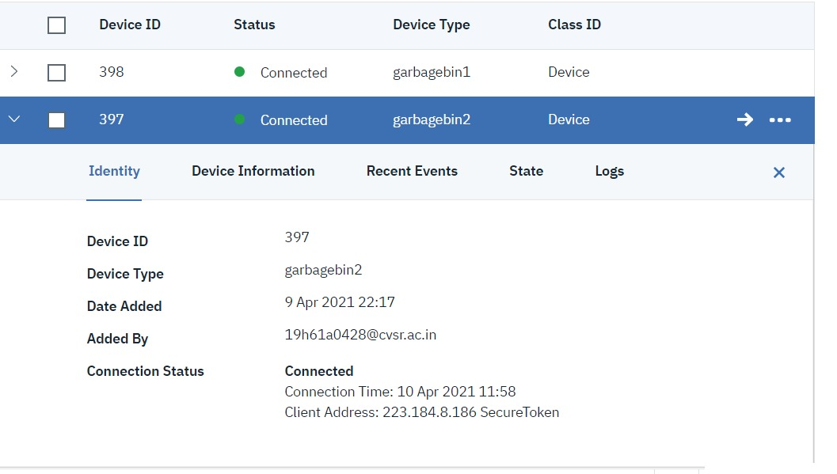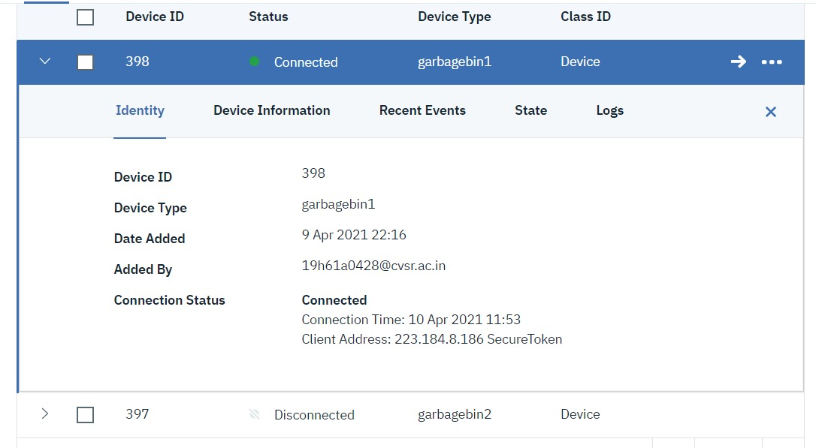

First, we have created 2 devices in IBM cloud for 2 garbage bins.
STEP2: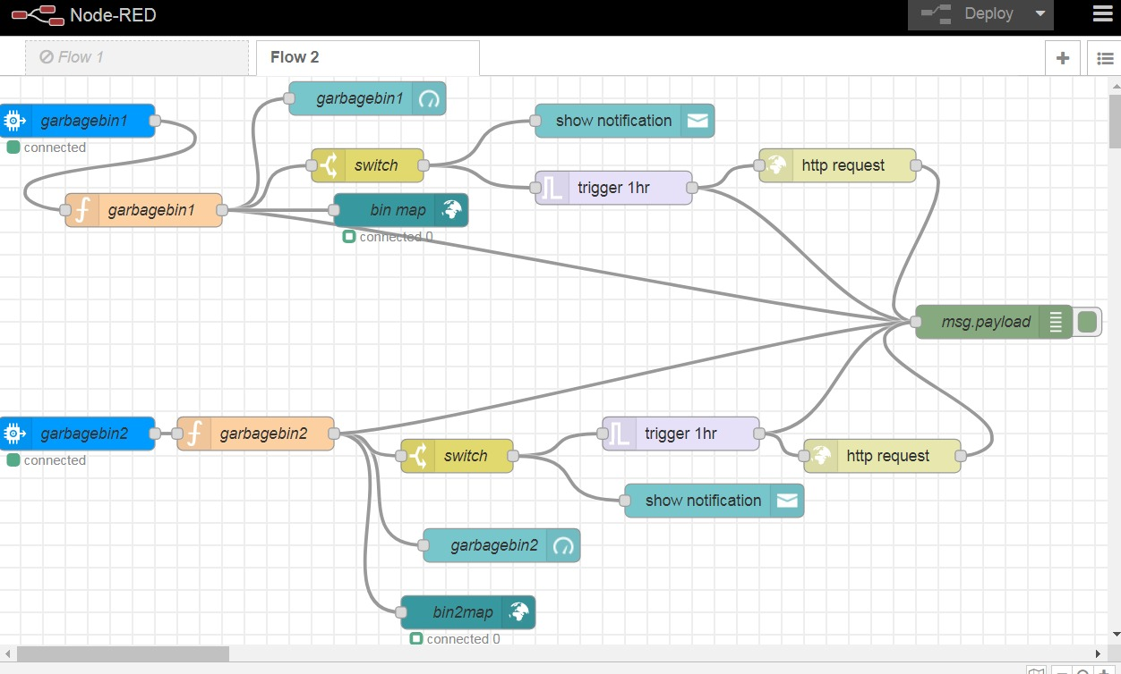

This is the flow for garbage management.

STEP 3:

PYTHON CODE:

FOR DEVICE 1:

import time
import sys
import ibmiotf.application
import ibmiotf.device
import random
import json
#Provide your IBM Watson Device Credentials
organization = "ud5wxj"
deviceType = "garbagebin2"
deviceId = "397"
authMethod = "token"
authToken = "Ravali@399"
# Initialize the device client.
g2=0
try:
deviceOptions = {"org": organization, "type": deviceType, "id": deviceId, "auth-method": authMethod, "auth-token": authToken}
deviceCli = ibmiotf.device.Client(deviceOptions)
#..............................................

except Exception as e:
print("Caught exception connecting device: %s" % str(e))
sys.exit()

# Connect and send a datapoint "hello" with value "world" into the cloud as an event of type "greeting" 10 times
deviceCli.connect()

while True:
g2=90

#Send bin2 to IBM Watson
data = {"d":{ 'iotdevice':g2 }}
#print data
def myOnPublishCallback():
print ("Published iotdevice = %s" % g2, "to IBM Watson")

success = deviceCli.publishEvent("Data", "json", data, qos=0, on_publish=myOnPublishCallback)
if not success:
print("Not connected to IoTF")
time.sleep(10)
# Disconnect the device and application from the cloud
deviceCli.disconnect()

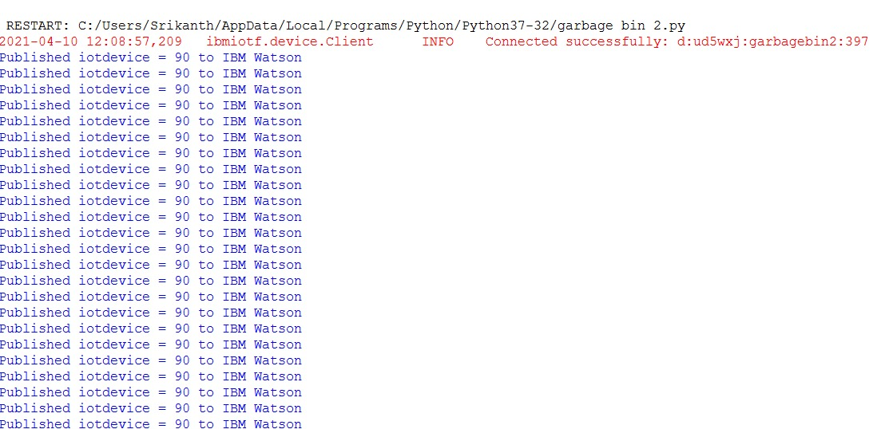

FOR DEVICE 2:

import time
import sys
import ibmiotf.application
import ibmiotf.device
import random
import json
#Provide your IBM Watson Device Credentials
organization = "ud5wxj"
deviceType = "garbagebin1"
deviceId = "398"
authMethod = "token"
authToken = "Ravali@399"
# Initialize the device client.
g1=0
try:
deviceOptions = {"org": organization, "type": deviceType, "id": deviceId, "auth-method": authMethod, "auth-token": authToken}
deviceCli = ibmiotf.device.Client(deviceOptions)
#..............................................

except Exception as e:
print("Caught exception connecting device: %s" % str(e))
sys.exit()

# Connect and send a datapoint "hello" with value "world" into the cloud as an event of type "greeting" 10 times
deviceCli.connect()

while True:
g1=20
#Send bin1 to IBM Watson
data = {"d":{ 'iotdevice':g1 }}
#print data
def myOnPublishCallback():
print ("Published iotdevice = %s" % g1, "to IBM Watson")
success = deviceCli.publishEvent("Data", "json", data, qos=0, on_publish=myOnPublishCallback)
if not success:
print("Not connected to IoTF")
time.sleep(10)

# Disconnect the device and application from the cloud
deviceCli.disconnect()
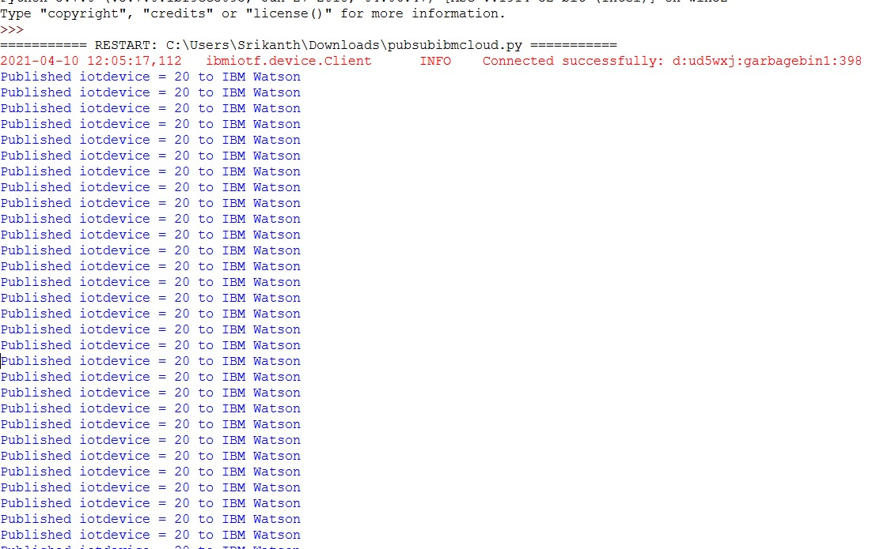
STEP4: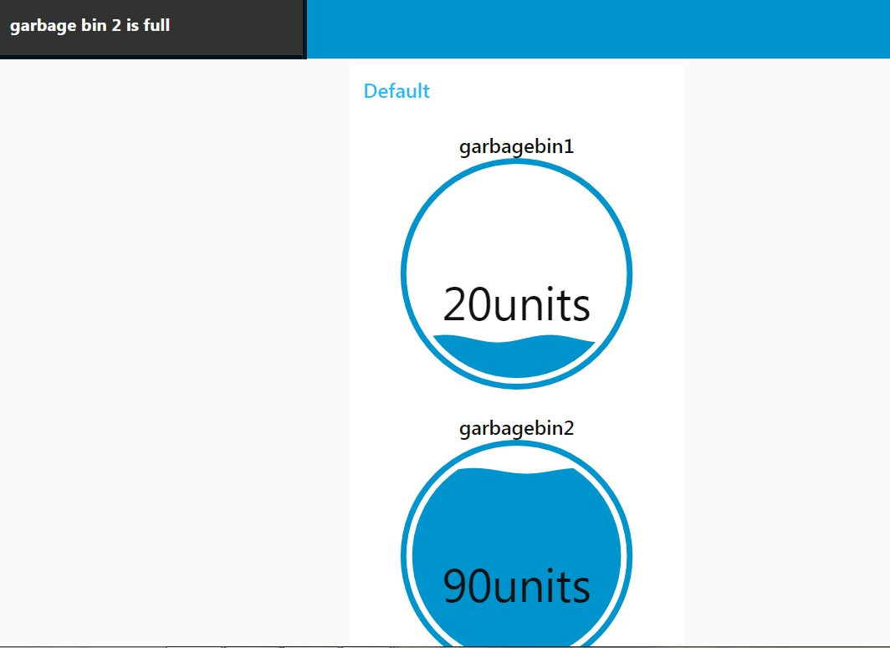

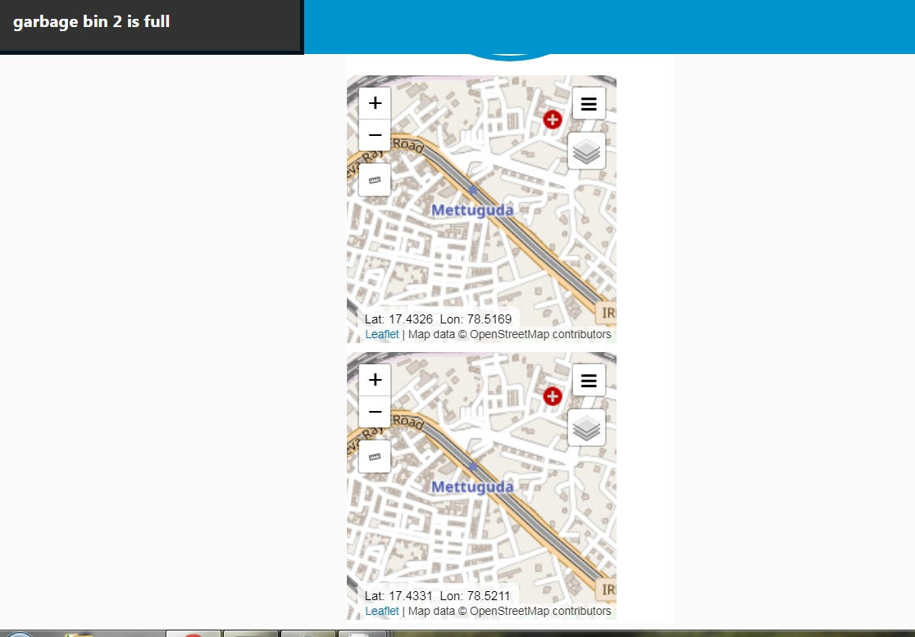
Next, level and location are displayed.

STEP5:



Checks if the garbage level is full and sends a message and notification.

